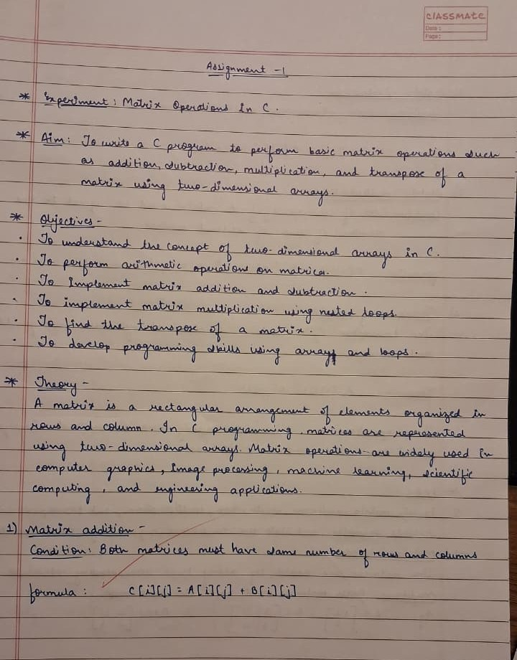
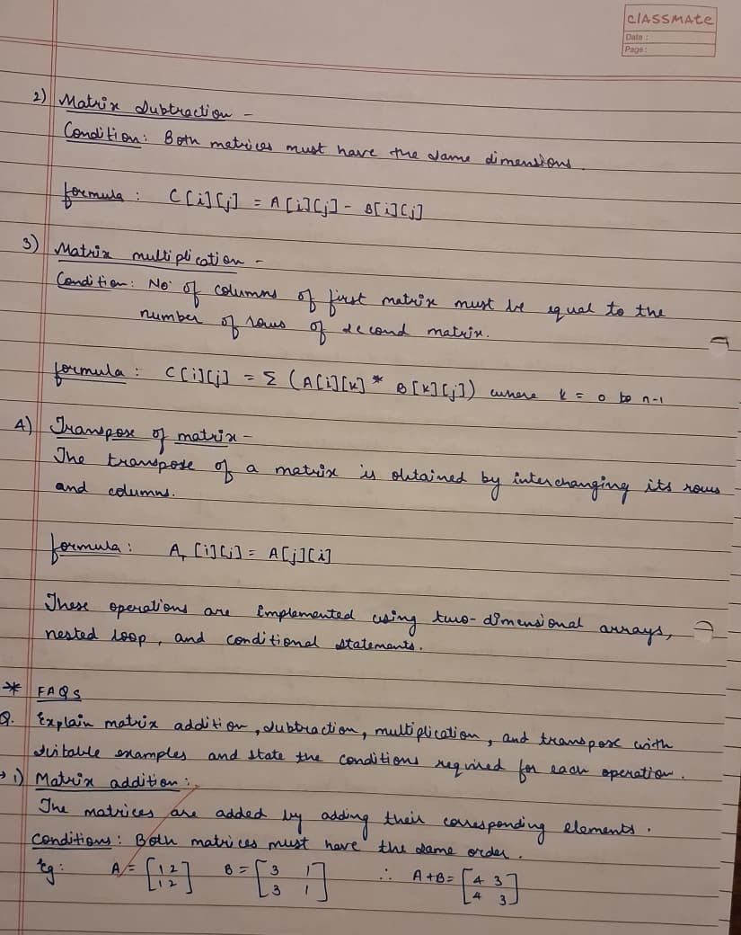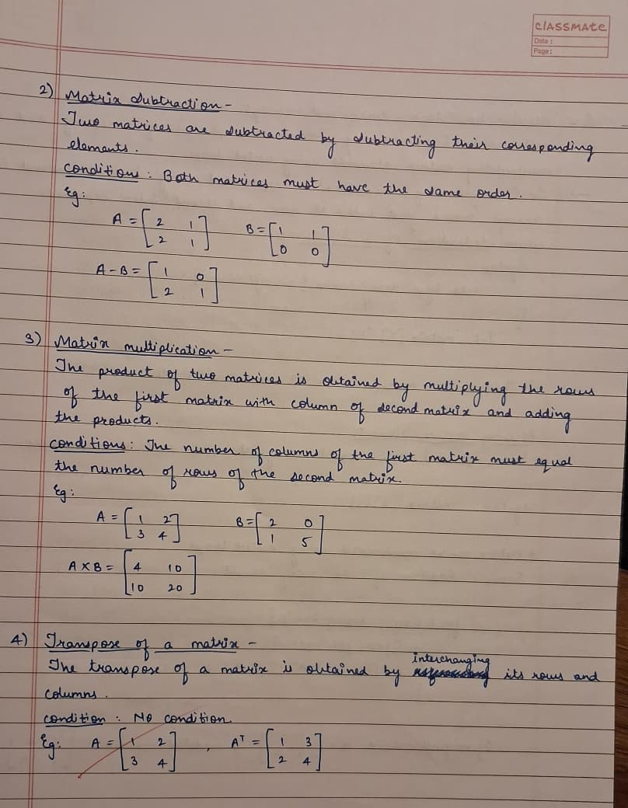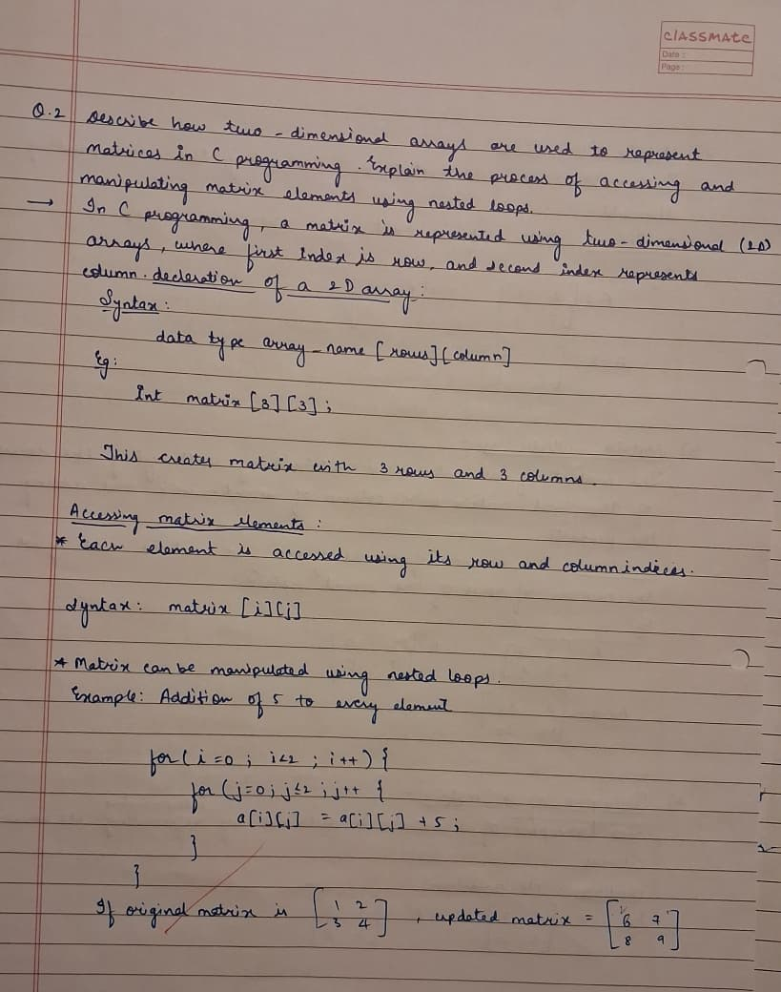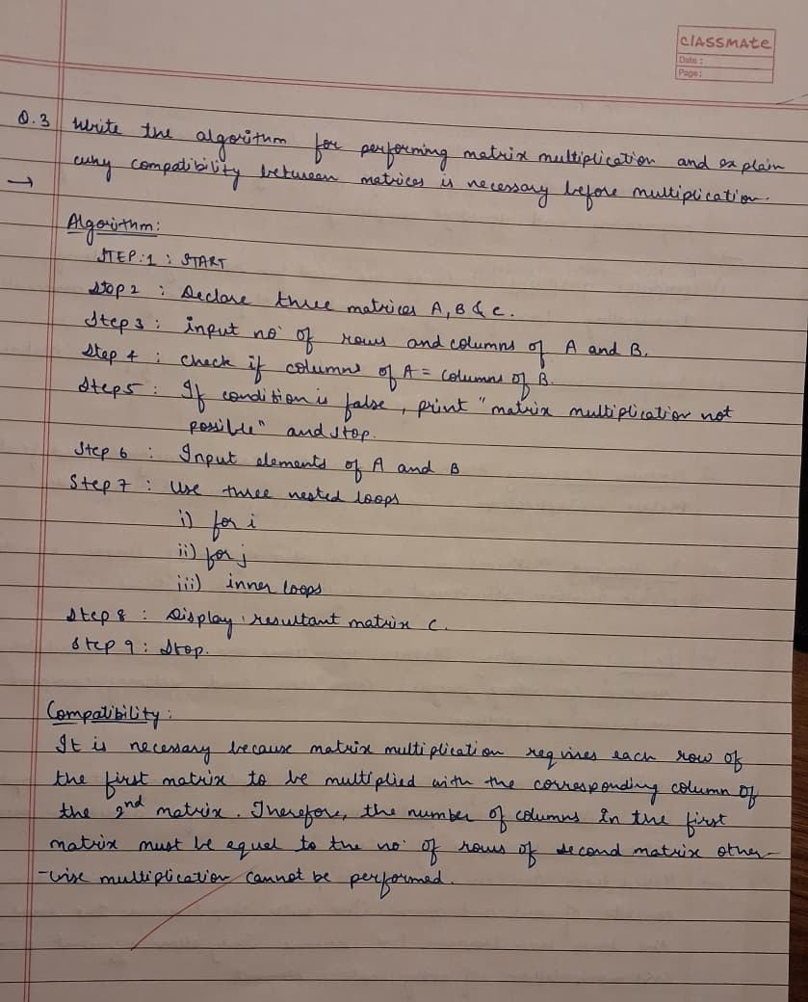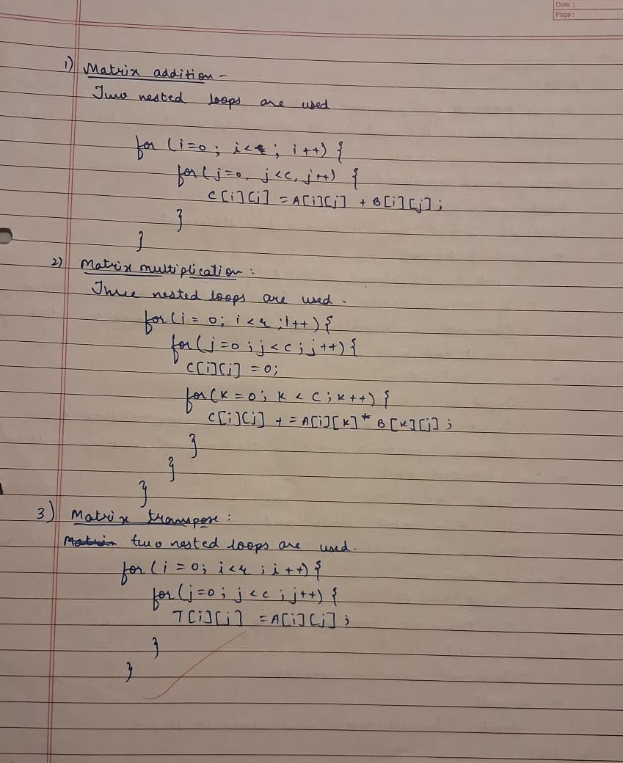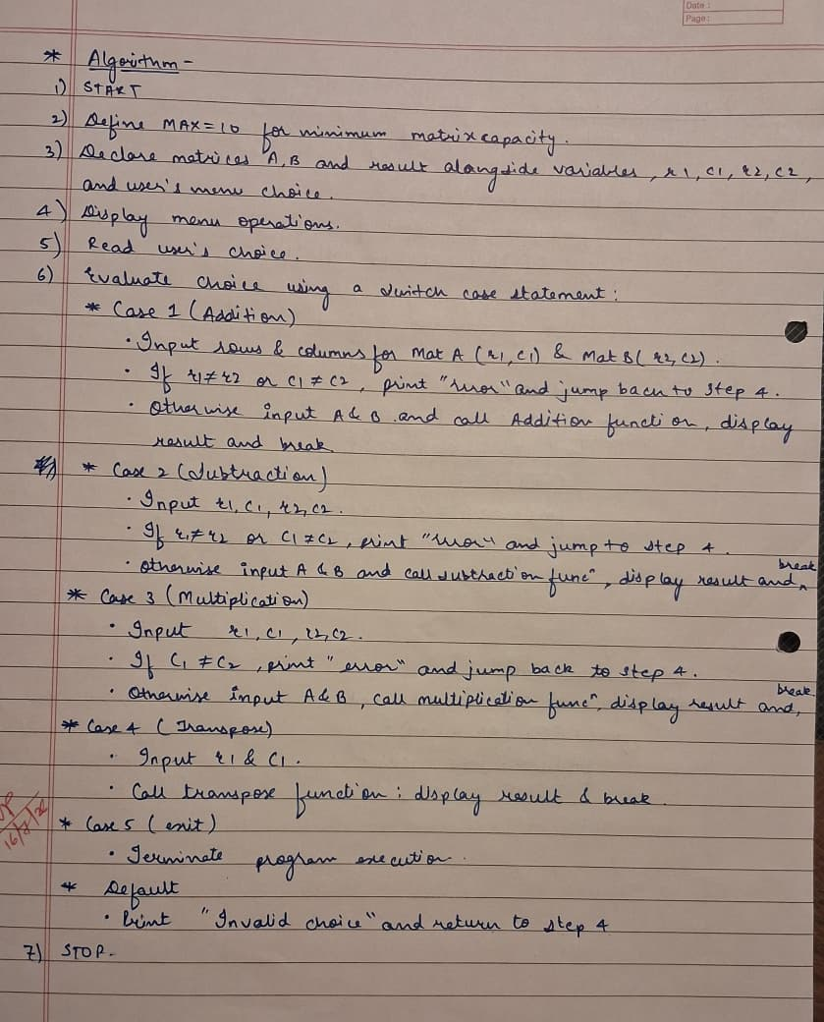

CODE:
#include <stdio.h>

#define MAX 10

void input (int matrix[MAX][MAX], int rows, int cols);
void display (int matrix[MAX][MAX], int rows, int cols);
void add (int a[MAX][MAX], int b[MAX][MAX], int result[MAX][MAX], int rows, int cols);
void subtract (int a[MAX][MAX], int b[MAX][MAX], int result[MAX][MAX], int rows, int cols);
void multiply (int a[MAX][MAX], int b[MAX][MAX], int result[MAX][MAX], int r1, int c1, int c2);
void transpose (int matrix[MAX][MAX], int result[MAX][MAX], int rows, int cols);

int main()
{
int a[MAX][MAX], b[MAX][MAX], result[MAX][MAX];
int r1, c1, r2, c2;
int choice;

while (1)
{
printf("\n--- Matrix Operations Menu ---\n");
printf("1. Addition of two matrices\n");
printf("2. Subtraction of two matrices\n");
printf("3. Multiplication of two matrices\n");
printf("4. Transpose of a matrix\n");
printf("5. Exit\n");
printf("Enter your choice (1-5): ");
scanf("%d", &choice);

switch (choice)
{
case 1:
printf("Enter rows and columns for Matrix A: ");
scanf("%d %d", &r1, &c1);
printf("Enter rows and columns for Matrix B: ");
scanf("%d %d", &r2, &c2);
if (r1!=r2||c1!=c2)
{
printf("\nError! Matrices must have the same order.\n");
break;
}
printf("\nEnter elements of Matrix A:\n");
input(a, r1, c1);
printf("\nEnter elements of Matrix B:\n");
input(b, r2, c2);
add(a, b, result, r1, c1);
printf("\nResultant Matrix (A + B):\n");
display(result, r1, c1);
break;

case 2:
printf("Enter rows and columns for Matrix A: ");
scanf("%d %d", &r1, &c1);
printf("Enter rows and columns for Matrix B: ");
scanf("%d %d", &r2, &c2);
if (r1 != r2 || c1 != c2)
{
printf("\nError! Matrices must have the same order.\n");
break;
}
printf("\nEnter elements of Matrix A:\n");
input(a, r1, c1);
printf("\nEnter elements of Matrix B:\n");
input(b, r2, c2);
subtract(a, b, result, r1, c1);
printf("\nResultant Matrix (A - B):\n");
display(result, r1, c1);
break;

case 3:
printf("Enter rows and columns for Matrix A: ");
scanf("%d %d", &r1, &c1);
printf("Enter rows and columns for Matrix B: ");
scanf("%d %d", &r2, &c2);
if (c1 != r2)
{
printf("\nError! Columns of Matrix A must equal rows of Matrix B.\n");
break;
}
printf("\nEnter elements of Matrix A:\n");
input(a, r1, c1);
printf("\nEnter elements of Matrix B:\n");
input(b, r2, c2);
multiply(a, b, result, r1, c1, c2);
printf("\nResultant Matrix (A * B):\n");
display(result, r1, c2);
break;

case 4:
printf("Enter rows and columns for the matrix: ");
scanf("%d %d", &r1, &c1);
printf("\nEnter elements of the matrix:\n");
input(a, r1, c1);
transpose(a, result, r1, c1);
printf("\nTransposed Matrix:\n");
display(result, c1, r1);
break;

case 5:
printf("Exiting program!\n");
return 0;

default:
printf("Invalid choice!\n");
break;
}
}
return 0;
}

void input(int matrix[MAX][MAX], int rows, int cols)
{
for (int i=0; i<rows; i++)
{
for (int j=0; j<cols; j++)
{
printf("Enter element [%d][%d]: ", i, j);
scanf("%d", &matrix[i][j]);
}
}
}

void display(int matrix[MAX][MAX], int rows, int cols)
{
for (int i=0; i<rows; i++)
{
for (int j=0; j<cols; j++)
{
printf("%d\t", matrix[i][j]);
}
printf("\n");
}
}

void add(int a[MAX][MAX], int b[MAX][MAX], int result[MAX][MAX], int rows, int cols)
{
for (int i=0; i<rows; i++)
{
for (int j=0; j<cols; j++)
{
result[i][j] = a[i][j] + b[i][j];
}
}
}

void subtract(int a[MAX][MAX], int b[MAX][MAX], int result[MAX][MAX], int rows, int cols)
{
for (int i=0; i<rows; i++)
{
for (int j=0; j<cols; j++)
{
result[i][j] = a[i][j] - b[i][j];
}
}
}

void multiply(int a[MAX][MAX], int b[MAX][MAX], int result[MAX][MAX], int r1, int c1, int c2)
{
for (int i=0; i<r1; i++)
{
for (int j=0; j<c2; j++)
{
result[i][j] = 0;
for (int k=0; k<c1; k++)
{
result[i][j] += a[i][k] * b[k][j];
}
}
}
}

void transpose(int matrix[MAX][MAX], int result[MAX][MAX], int rows, int cols)
{
for (int i=0; i<rows; i++)
{
for (int j=0; j<cols; j++)
{
result[j][i] = matrix[i][j];
}
}
}

OUTPUT:
